Year 11 History
2AHIM Societies and Change- USA between the wars
Document Study

Source 1
Name: ___________________________________

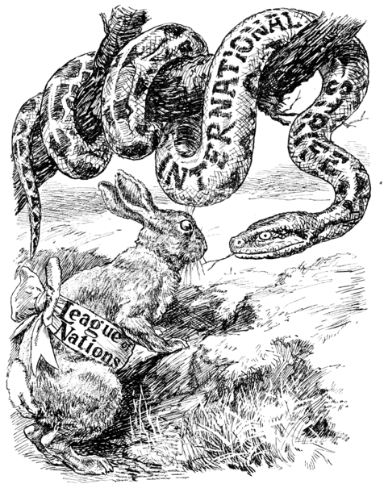

Moral Suasion.
The Rabbit. "My offensive equipment being practically nil, it remains for me to fascinate him with the power of my eye."

Cartoon from Punch magazine, July 28 1920.

Source 2
Senator Henry Cabot Lodge. His case against Wilson's League of Nations, "I think of the United States first." (1919)

The United States is the world's best hope, but if you fetter [tie] her in the interest through quarrels of other nations, if you tangle her in the intrigues of Europe, you will destroy her powerful good, and endanger her very existence. Leave her to march freely through the centuries to come, as in the years that have gone. Strong, generous, and confident, she has nobly served mankind. Beware how you trifle with your marvellous inheritance -- this great land of ordered liberty. For if we stumble and fall, freedom and civilization everywhere will go down in ruin.

http://memory.loc.gov/cgi-bin/query/

Senator Gilbert Hitchcock. “The trouble with Senators who oppose the League of Nations” (1919)
The trouble with Senators who oppose the League of Nations is that they are thinking of the days that are gone and gone forever. The conquering empires of the world have been wiped out. The fall of Russia and Germany and Austria-Hungary removed from the world the last representatives of the conquering spirit and of autocratic power. The world is now democratic. Senators should cease to turn their eyes to the past and should turn them to the future, and see what we have before us.
…
The late war cost seven million lives, and millions more of cripples. It has destroyed hundreds of towns, it has widowed millions of wives, it has brought in its train the inevitable consequences of war, pestilence, and famine. One of the war diseases alone has cost this country over three hundred thousand lives of the civilian population. It has let loose and inflamed the passions and lusts of man, and crushed and humiliated millions of women. Massacre, torture, and assassinations have accompanied it. Law and order have been overthrown. Bolshevism (communism) and anarchy have been profligated. The confidence of men in government has been shaken. It will never be restored until governments devise some way to end war. The League of Nations is that way.
http://memory.loc.gov/cgi-bin/query/

Source 3

Source 4

Extract from one of President Woodrow Wilson's
Final Addresses in Support of the League of Nations,
25 September 1919, Pueblo, CO
There is one thing that the American people always rise to and extend their hand to, and that is the truth of justice and of liberty and of peace. We have accepted that truth and we are going to be led by it, and it is going to lead us, and through us the world, out into pastures of quietness and peace such as the world never dreamed of before.
http://www.firstworldwar.com/source/wilsonspeech_league.htm

- Outline the message in Source 1 and explain how this message is portrayed. {3 marks}
____________________________________________________________________________________________________________________________________________________________________________________________________________________________________________________________________________________________________________________________________________________________________________________________________________

- Contrast the attitudes about America’s involvement in the League of Nations expressed in Sources 2 and 3. {3 marks}
____________________________________________________________________________________________________________________________________________________________________________________________________________________________________________________________________________________________________________________________________________________________________________________________________________

- What is the context of Source 4? That is the people, action or events surrounding the source. {2 marks}
____________________________________________________________________________________________________________________________________________________________________________________________________________________________________________________________________________________________________________________________________________________________________________________________________________

- Compare the messages in Sources 3 and 4 {3 marks}
____________________________________________________________________________________________________________________________________________________________________________________________________________________________________________________________________________________________________________________________________________________________________________________________________________

- How useful are these sources for an historian investigating the period? Your answer may include comments on reliability, relevance, bias and purpose. {4 marks}
____________________________________________________________________________________________________________________________________________________________________________________________________________________________________________________________________________________________________________________________________________________________________________________________________________
________________________________________________________________________________________________________________________________________________________________________________________________________________________________________________________________________

